**My Read Me Document.**

Contents

**My flashcard quiz application’s user interface.** 2

**Report about my Flashcard Quiz Application.** 3

**Referencing.** 4

Bibliography 4

**Welcome.**

Greetings ladies and gentlemen. My name is **Luvo Tshangela** from the IIE Varsity College in Pretoria and this is my assignment presentationfor my **Flashcard Quiz Application for** Introduction to Mobile Applicationlication Development.

# **My flashcard quiz application’s user interface.**

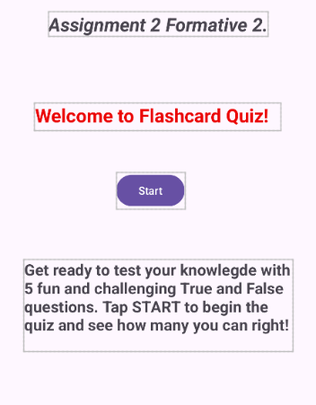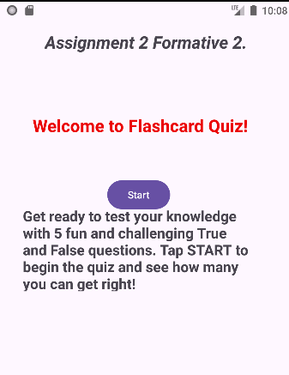

Figure : This is a picture of my activitymain.xml welcome screen.

Figure 2: This a preview of my MainActivity.kt welcome screen .

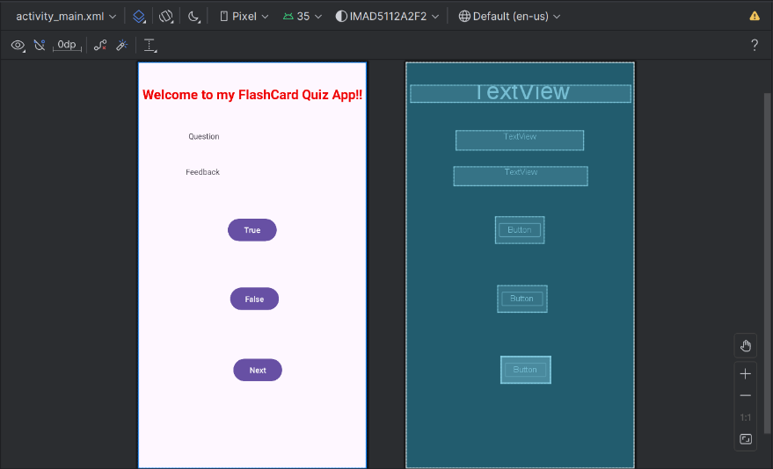

Figure 3: This my a preview of my activitymain.xml flashcard question screen.

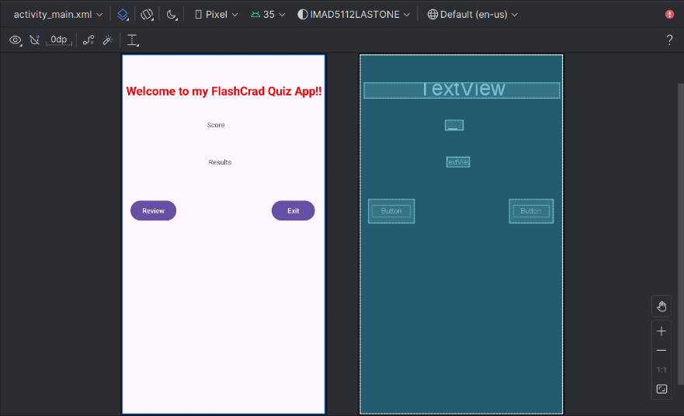

Figure 4: This is a preview of my activitymain.xml score screen.

# 

# **Report about my Flashcard Quiz Application.**

The purpose of my flashcard quiz application is to use a popular study tool to test knowledge on various subjects that requires me to create an application on Android Studio using Kotlin to help users study with flashcards. The applicationlication user interface consists of a welcome screen, flashcard question screen and a score screen. The design considerations used on this application were complex only a Text View, Edit Text and a Button were used to create the application user interface. The applications logic was created on MainActivity.kt using Kotlin.

# **Referencing.**

# Bibliography

ChatGpt, 2025. *Source code on how to create a Flash card Quiz App?,* s.l.: AI.

Education, T. I. I. o., 2025. *Introduction to Mobile Develpment and Application Module Mannual.* IMAD5112/p/w ed. s.l.:The IIE.